**Chicken Wing Dissection**                Name:________________________

**Aims**

* To study the internal structures of a chicken wing
* To identify a pair of antagonistic muscles
* To identify tendons and ligaments
* To identify types of joints in a chicken wing

**Equipment**

Chicken wing

Cutting board

Newspaper

Dissecting scissors

Forceps

Disposable gloves

Disinfectant

**Safety**

* Raw chicken may be contaminated by Salmonella, a pathogenic bacterium. It is recommended you wear gloves and wash your hands at the end of the dissection.
* All scissors and forceps should be placed in disinfectant after use.
* Benches should be wiped down with disinfectant at the end of class.

**Method**

1. Put on gloves, place two sheets of newspaper on the bench and lay the cutting mat on top of the newspaper.
2. Collect the chicken wing and dissecting equipment.
3. 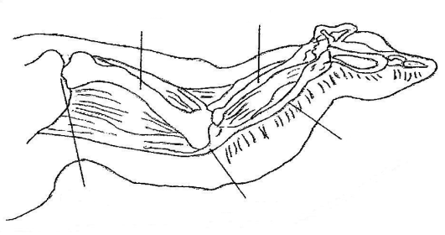Imagine the wing is your arm. Move the joints and look at the picture below.

Joint A

Joint B

* 1. **Which joint in the human arm is the equivalent to joint A?**
  2. **Which joint in the human arm is the equivalent to joint B?**
  3. **What type of joint is joint A? Give a reason for your choice.**
  4. **What type of joint is joint B? Give a reason for your choice.**
  5. **Label the three bones in chicken wing.**

1. Examine the skin covering the chicken wing. **Describe the skin (colour, texture etc.)**
2. Examine the wing at the point where it was removed from the body. **Describe the cartilage on the end of the bone (colour, texture, etc.)**
3. 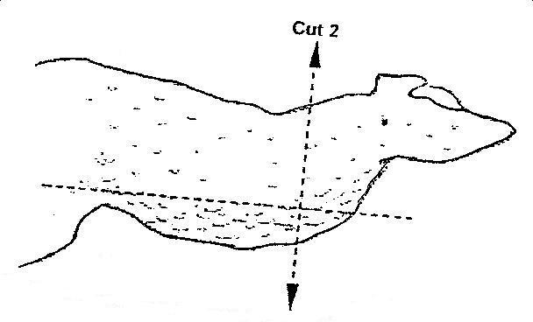Using the scissors, cut down the middle of the skin, as shown in cut 1. Then, cut down the sides of the skin to make a T-shaped cut, as shown in cut 2. Peel the skin and cut it away to reveal the muscles below. **Take your time and try not to cut the tissue below the skin.**

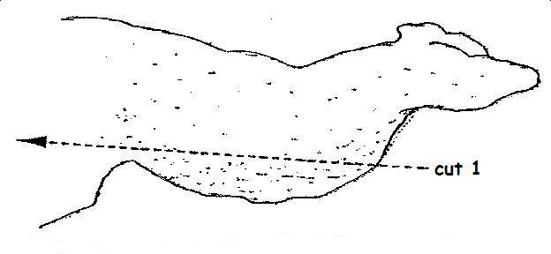

1. Identify the fat below the skin. **Describe the fat.**
2. Identify the muscles of the wing. **Describe the muscles.**
3. Tendons attach muscles to bones. Locate a tendon. **Draw and describe a tendon in the space below.**
4. Hold the wing down by the shoulder and alternately pull on each muscle. Observe and record what happens by drawing diagrams in the space below.
5. Carefully cut away the muscles from around a joint. **Locate and describe the ligaments that join the bones together.**
6. Dislocate the elbow joint. **Describe and identify the type of joint in the elbow. Draw the two ends of the bones that form the joint.**
7. **Describe the surface of the bones.**
8. Carefully break one of the bones into two. **Describe the inside of the bone.**
9. Wrap all chicken pieces in the newspaper and place in the bin provided. Carefully wash the cutting mat and dissecting tools in soapy water. Place the dissecting tools in the disinfectant. Wipe down your desk with disinfectant.

**Follow-up Questions**

1. What type of tissue moves the chicken wing?
2. What role do tendons play in moving bones?
3. Which bone in the wing is connected to the chicken’s body at the shoulder?
4. Name the two bones found in the forearm of the wing.
5. What type of joint moves the wing at the elbow?
6. What type of joint is found in the shoulder?
7. What is the purpose of cartilage in the joints?
8. What are ligaments and what is their function?